Leaky ReLUs are utilized to avoid zero gradients that are present in ReLU networks. At times, due to the zero portion of the ReLU activation function, neurons in the neural network will sometimes reach a value of zero and a gradient of zero and will never change. These neurons will have no effect on the learning of the neural network no matter how much training is done and therefore a small “leakage” is implemented to avoid the zero gradient so that these neurons can move away from being “dying”.

[arXiv:1502.01852](https://arxiv.org/abs/1502.01852)

AlexNet is the first of the four networks presented and was the first network to primarily utilize stacked convolutional layers utilizing GPUs for increased speed to run. It had a similar but deeper structure to LeNet from 14 years before, where GPUs were not yet utilized for machine learning. Its defining feature was the large amounts of convolutional filters and more stacked convolutional layers that made it outperform the state of the art in 2012.

<https://papers.nips.cc/paper/4824-imagenet-classification-with-deep-convolutional-neural-networks.pdf>

GoogleNet is the second oldest of the four networks. It followed the same architecture as AlexNet but reduced the number of parameters utilized for learning. It utilizes a series of very small convolutions to reduce the number of features utilized and improved image recognition to around human performance levels. It utilizes 22 convolutional layers but significantly reduced the number of parameters.

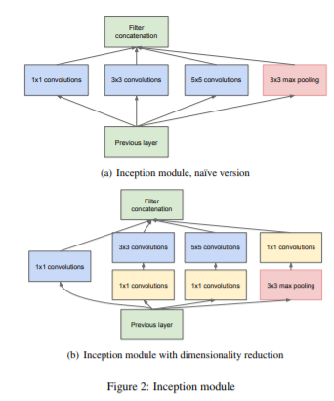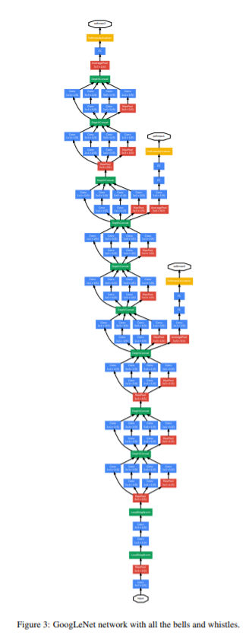

<https://www.cs.unc.edu/~wliu/papers/GoogLeNet.pdf>

VGGNet is a convolutional neural network consisting of 16 convolutional layers. It has a very uniform structure utilizing specifically 3x3 convolutional filters and 2x2 max-pooling windows. It is preferred for use due to this uniform structure making it easy to build and use for image recognition. The performance is just as good as GoogleNet’s performance while the architecture is a bit simpler.

arXiv:1409.1556

ResNet is a network built by Kaiming He that utilizes something called residual learning to improve performance of the neural network for image classification to a point greater than a human’s. Its defining characteristic is the residual building block not present in the other neural networks such as AlexNet, GoogleNet, and VGGNet.

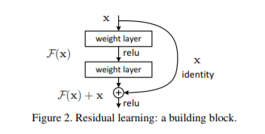

These skip/shortcut connections attempt to solve a problem that very deep networks have that training error grows with increased depth.

arXiv:1512.03385